**Ideation Phase**

**Define the Problem Statements**

|  |  |
| --- | --- |
| Date | 31 January 2025 |
| Team ID | LTVIP2025TMID60795 |
| Project Name | Pattern Sense: Classifying Fabric Patterns Using Deep Learning |
| Maximum Marks | 2 Marks |

**Customer Problem Statement Template:**

The Pattern Sense Customer Problem Statement template helps you focus on what matters most to develop intelligent fabric pattern classification experiences that designers and manufacturers will love.

A well-articulated problem statement allows our team to identify the ideal deep learning solution to the real-world challenges users face when manually classifying fabric patterns. Throughout the process, we’ll gain empathy for our users—fashion designers, textile producers, and AI engineers—helping us better understand how they interact with and perceive the value of our automated pattern recognition system.

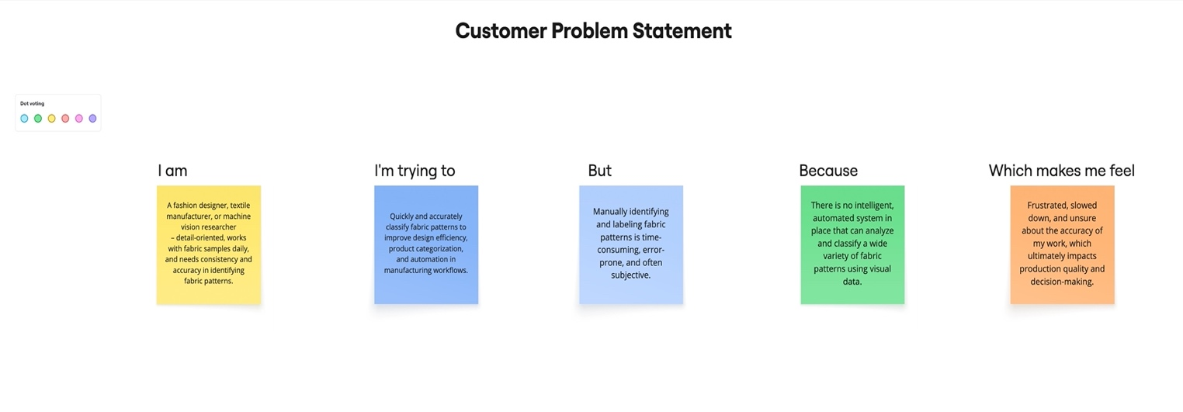**Example:**

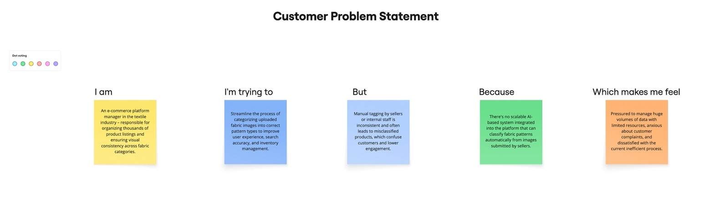

|  |  |  |  |  |  |
| --- | --- | --- | --- | --- | --- |
| **Problem Statement (PS)** | **I am (Customer)** | **I’m trying to** | **But** | **Because** | **Which makes me feel** |
| PS-1 | |  | | --- | |  |   A fashion designer, textile manufacturer, or machine vision researcher – detail-oriented, works with fabric samples daily, and needs consistency and accuracy in identifying fabric patterns. | Quickly and accurately classify fabric patterns to improve design efficiency, product categorization, and automate manufacturing workflows. | Manually identifying and labeling fabric patterns is time-consuming, error-prone, and often subjective. | There is no intelligent, automated system in place that can analyze and classify a wide variety of fabric patterns using visual data. | Frustrated, slowed down, and unsure about the accuracy of my work, which ultimately impacts production quality and decision-making. |
| PS-2 | An e-commerce platform manager in the textile industry – responsible for organizing thousands of product listings and ensuring visual consistency across fabric categories. | Streamline the process of categorizing uploaded fabric images into correct pattern types to improve user experience, search accuracy, and inventory management. | Manual tagging by sellers or internal staff is inconsistent and often leads to misclassified products, which confuse customers and lower engagement. | There's no scalable AI-based system integrated into the platform that can classify fabric patterns automatically from images submitted by sellers. | Pressured to manage huge volumes of data with limited resources, anxious about customer complaints, and dissatisfied with the current inefficient process. |